**Ideation Phase**

**Define the Problem Statements**

|  |  |
| --- | --- |
| Date | 19 September 2022 |
| Team ID | PNT2022TMID50136 |
| Project Name | Project – Statistical Machine Learning Approaches to Liver Disease Prediction |
| Maximum Marks | 2 Marks |

**Problem Statement**

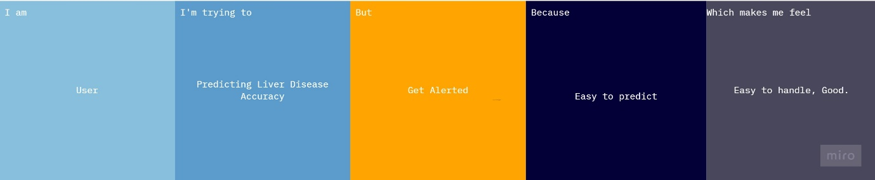

Reference : https://miro.com/app/board/uXjVPRB34MY=/

|  |  |  |  |  |  |
| --- | --- | --- | --- | --- | --- |
| **Problem Statement (PS)** | **I am (User)** | **I’m trying to** | **But** | **Because** | **Which makes me feel** |
| PS-1 | User | Trying to Predict My Liver Disease | it’s difficult to calculate | it takes more time | Challenging. |
| PS-2 | User | Finding the Accuracy | it’s hard to gathering information | i don’t have enough information | disappointed |
| PS-3 | User | Finding The Solution to the disease | it’s hard | it takes long time | disappointed |